Spiritual Freedom and economic prosperity: approach from Pope Francis.
Frederic BOMBA

Abstract
This paper investigates the relationship between spiritual freedom and economic prosperity using the Pope Francis spiritual freedom’s definition, with a focus on the role of education, religious freedom and gender equity. By analyzing cross-sectional data from 74 countries in 2023, the study investigates how these factors influence the GDP per capita. The empirical results show that spiritual freedom, particularly through education (measured by the Adult Literacy Rate (ED)) has a significant impact on economic prosperity but government restrictions on religion and gender equity (measured by the Health and Survival Index (GE)) tend to negatively affect economic growth. The paper also reveals regional differences, with some effects in European and American countries. The conclusion is the finding of the role of spiritual freedom in economic prosperity, particularly in regions with higher Adult Literacy Rate (ED)s.
Keywords: Spiritual freedom, religious freedom, education, gender equity, economic prosperity.

Introduction
The determinants of economic prosperity have long been searched by many scholars. For neoclassical economics, the main factors of economic growth and prosperity are physical capital and financial capital. According to the endogenous growth theory, human capital and other elements such as technological innovation are key drivers concerned. While many scholars are interested in tangible elements such as the latter, others think that intangible factors such as spiritual freedom or ethics are also relevant drivers of economic prosperity. Therefore, one can ask whether spiritual freedom can lead to economic prosperity. But what is spiritual freedom? Pope Francis (2015) sees education, religious freedom, and other civil rights, such as gender equity, as essential for spiritual freedom. As an element of social capital, spiritual freedom can contribute to economic prosperity through well-being, creativity and then personal fulfillment, productivity and innovation. Moreover, spiritual freedom promotes inclusivity and then diversified economic interlinkages can lead to prosperity.
This paper aims to empirically examine how spiritual freedom can lead to economic prosperity, by borrowing the Pope’s concept of spiritual freedom through education, religious freedom and gender equity. To do so, the study conducts analysis through the relationships between GDP per capita and Health and Survival Index (GE), Adult Literacy Rate (ED), and Government Restriction Index (RE) in 2023. In doing so, this paper contributes to the literature in intangible means and economic prosperity. This paper is organized as follows. Section I provides a literature review and presents testable hypotheses. In section II, spiritual freedom is decomposed into different dimensions and each one is explained. In section III, the hypotheses are tested across economies, followed by analysis and discussion at the regional level. Then, we recapture the main findings and conclude the paper.

- Literature review and articulation of hypotheses
Throughout history, people have always been persecuted, for their ethnic origin or race, their beliefs or other reasons. In fact, there is no group in the world that does not suffer to some degree because of its beliefs. Freedom is the condition in which we “live our lives as we choose so long as we respect the equal rights of others” and have no coercion. According to John F. Early (2023) freedom has frequently been associated with economic prosperity. But, is spiritual freedom concerned? A comparison of ratings for religious freedom with freedom house’s ratings for political rights and civil liberties allow us to see how the degree of religious freedom in a country correlates with its record of human rights in general. We can thus think that spiritual freedom and other freedoms will usually go together.
Spirituality can significantly contribute to the development of nations... For instance, Robert Woodberry (2012) found that the presence of proselytizing Protestant faiths, was associated with economic development throughout the world. Other faith-based associations have increased education through the establishment of seminaries, have disseminated books, and founded hospitals and schools for women, improving gender equity. Contributions of this type are not just a legacy from the past. Katherine Marshall, former director of the Development Dialogue on Values and Ethics at the World Bank, recognized that present-day faith communities not only provide education and health services, but also provide social safety nets for orphans, disabled people, and people who fall behind (Pew Forum 2006). Gill A, Owen JMIV (2017) found four important roles for spiritual freedom: it promotes diversity, security, and Prosperity, it attracts entrepreneurs who foster economic growth, it fosters a commercial society and tends to spread to neighboring countries. Moreover, authors of the report Religious Liberty & Economic Prosperity: Keys to America’s Future argue that “spiritual freedom promotes and preserves religious pluralism in a country, which is strongly linked to a sustained culture of innovation… fosters certain types of religious competition that have substantial benefits for education, literacy, civil society, and democratization’’. In fact, there is “substantial evidence of the positive role religious communities and faith-based organizations play in promoting sustainable development goals.” In other words, where spiritual liberty flourishes, we see evidence of stronger economies. In a recent study done by researchers at Georgetown University and Brigham Young University, freedom of belief is one of three factors significantly associated with global economic growth. The study looked at the GDP growth of 173 countries in 2011 and controlled two-dozen different financial, social and regulatory influences.
According to Fox. J (2001) Religious freedom is important because it is posited to be a central element of liberal democracy and as having multiple additional benefits including increased security and economic prosperity. Yet, it is also a disputed concept, and many liberal democracies restrict the freedoms of religious minorities. A recent literature argues that spiritual freedom has economic benefits. Many argue that supporting religious freedom also promotes economic prosperity (Gill, 2008). This author links religious and spiritual freedom and economic prosperity. It increases people’s interactions across religions which reduces cultural barriers to trade and increases economic activity.
When it comes to education, it is a leading determinant of economic growth even though understanding its influence is not a direct point. According to Woessman (2015), ignoring the economic dimension of education would endanger the prosperity of future generations, with widespread repercussions for poverty, social exclusion, and sustainability of social. A considerable amount of evidence on the positive economic effects of completed primary education, secondary education and tertiary education has been generated over the past 40 years (UNESCO 2010).
Concerning gender equity, Fluchtmann, J., W. Adema and M. Keese (eds.) (2024) show that closing gender gaps in labor force participation and working hours can have substantial effects on output growth. Consequently, countries with larger baseline gender gaps stand to benefit more from closing these gaps, while those with smaller gaps would see more limited effects.
In explaining the role of these three factors components of spiritual freedom, all these scholars allow us to assume that spiritual freedom is essential for economic prosperity. Therefore, this paper proposes and tests the following hypotheses:
Hypothesis 0. Spiritual freedom has no effect on economic prosperity.
Hypothesis 1. Spiritual freedom has an effect on economic prosperity.

- Decomposition of spiritual freedom
To test for the hypotheses articulated above, spiritual freedom is decomposed into three different dimensions following the definition of Pope Francis. We distinguish between education, religious freedom and civil rights such as gender equity. Because of education’s benefits for society and the poor and the fact it contributes to the common good of society, the fact that religious freedom is one of the minimum requirements to live in dignity and that gender equity is essential for spiritual freedom, Pope Francis defines this concept by these three elements. To do this study, we have been inspired by the work of Ilan Alon and Gregory Chase (2005) in their article Religious freedom and economic prosperity in Cato journal. With this in mind, the model of this paper is designed to account for the effects of education, religious freedom and gender equity in economic prosperity by employing data from the World Bank Database and from the Fordham Pope Francis Global Poverty report 2024 whose sources are the UNESCO database for the Adult Literacy Rate (ED) (measure of education), the world bank database for the Gender Restriction Indicator (Health and Survival Index (GE)) and the Pew Research Center data base for the Government Restriction Index (RE)(religious freedom).
- The Adult Literacy Rate (ED): it is the percentage of the population aged 15 and above who can read, write, comprehend a simple statement about their everyday life and continue to learn. It measures the basic minimum level of education that anyone should have.
-The Government Restrictions Index (RE) (as a metric to measure religious freedom): it accounts for the role of government institutions in promoting or deterring religious freedom.
-The Health and Survival Index (GE). This Index aggregates two components: sex ratio at birth, and the gender gap in healthy life expectancy.
To measure economic prosperity, the Log GDP per capita (LogC) will be used. It is the sum of gross value added by all resident producers in the economy plus any product taxes and minus any subsidies not included in the value of the products. It is calculated without making deductions for depreciation of fabricated assets or for depletion and degradation of natural resources. Data are in current U.S. dollars.
- Economic analysis and Decomposition
The empirical model used for this analysis is presented below. The period of investigation is the year 2023 when we use the log form for the dependent variable, because of the size of GDP. We use data of 74 countries from Africa, America, Asia and Europe. They are listed in the appendix. Some of them are developed countries while most are developing countries.
LogGC​ = β0 ​+ β1 ​(ED) - β2​ (RE) + β3 ​(GE) + ϵ
LOGC​: Dependent variable
ED: Independent variable.
RE: Independent variable.
GE: Independent variable.
ϵ: Error term (captures unobserved factors affecting GDP per capita)
Expectations are to have a positive β1, a negative β2, (religious freedom is positive for economic prosperity. Therefore, the restrictions made by a government on religious freedom should have negative effects) and a positive β3 (the integration of women in the society’s activities should be positive). There is no concern for either multicollinearity or heteroscedasticity.
Table 1 and 2 provide the results of the analysis using cross sectional data from 2023.
In table 1, the results are presented for the whole sample of countries (74) even though we noticed that two values were missing. Though the equation is:
LogGC= 3.12 ​+ 1.36 ​(ED) – 0.21​ (RE) – 0.11 ​(GE)
P-value of B1 is less than 0.001 therefore less than 0.1 (10%), the null hypothesis is wrong and B1 is statistically significant at the 10% level and ED has a significant relationship with LogGDP per capita.
The comparison between the global sample and each continent enables us to identify whether the effects of spiritual freedom differ in Africa, Europe, Asia or America.
In the global sample, spiritual freedom explains 57% of economic prosperity. Concerning each component, increasing one unit in the Adult Literacy Rate (ED) will increase GDP per capita by 137% holding other variables constant. That means that the higher the Adult Literacy Rate (ED), the higher the GDP per capita. However, the results also show that the higher the Government Restriction Index (RE) or the Health and Survival Index (GE), the lower the GDP per capita, holding other variables constant. The results of the Adult Literacy Rate (ED) and the Government Restriction Index (RE) are intuitive and are those we were expecting. But the Health and Survival Index (GE)’s results are counter intuitive and contrary to what the literature says.
When the sample is limited to groups, the results show quite a different outlook:
For European countries (9 countries over 74 in the sample), we got this equation:
LogGC​ = 7.63 ​– 3.02 ​(ED) – 0.42​ (RE) – 0.018 ​(GE)
That means that even the Adult Literacy Rate (ED) has a bad influence on the GDP per capita and the model explains 51% of the phenomenon. No coefficient is statistically significant at 10%. Even if we had a R2 of 51%, the model doesn't include important variables that influence the dependent variable.
For Asian countries (17 countries over 74 in the sample), we got this equation:
LogGC​ = 3.39 ​+ 1.06 ​(ED)+ 0.09​ (RE) – 0.43 ​(GE) and only 46% of the phenomenon is explained by the predictors. P-value ED =0.01. Therefore, ED is statistically significant at 10%.
For African countries, (32 countries over 74 in the sample), we got this equation:
LogGC= 3.63 ​+ 0.92 ​(ED) – 0.52​ (RE) – 0.21 ​(GE) and the model explains 42% of the phenomenon. P-value EDUCATION=0.0013. P-value RELIGION=0.07. Therefore, ED and RE are statistically significant at 10%.
For American countries (16 countries over 74 in the sample), we got this equation:
LogGC= 1.66 ​+ 1.96 ​(ED) – 0.44​ (RE) + 1.29 ​(GE) and the model explains 55% of the phenomenon. P-value EDUCATION=0.06. P-value GENRE=0.02. Therefore, ED and GE are statistically significant at 10%.
This comparison suggests that when the literature talks about the positive effects of spiritual freedom on economic prosperity, the countries most concerned are those of America.
The decomposition analysis shows an effect of spiritual freedom on GDP per capita in general. These findings disclose its importance in America. Regarding the effects of individual variables, Adult Literacy Rate (ED) is an important determinant that leads to economic prosperity.

Conclusion
The findings of this study recapture the role of spiritual freedom defined by Pope Francis through education, religious freedom and gender equity in achieving economic prosperity. There is indeed a positive correlation between spiritual freedom and GDP per capita. The key driver of this relationship is the Adult Literacy Rate (ED). In fact, the higher the literacy rate, the higher the GDP per capita. But, concerning government restrictions on religion and gender equity measured by the Health and Survival Index (GE), they tend to negatively impact economic prosperity.
While in European countries spiritual freedom had a negative effect on GDP per capita, with the Adult Literacy Rate (ED) and Government Restrictions Index (RE) showing this negative correlation, in Asian countries and African countries the Adult Literacy Rate (ED) positively impacted it: in the first case gender equity and religious restrictions had smaller effects. African countries share the global trend, adult literacy was positively correlated with GDP per capita but, religious freedom and gender equity had negative effects. In American countries, spiritual freedom had a notable positive impact, with Adult Literacy Rate (ED) and Health and Survival Index (GE) showing positive relationships with economic prosperity.
Finally, the study highlights the importance of spiritual freedom in improving economic prosperity, especially in America. However, the results for the Health and Survival Index (GE) were counterintuitive, suggesting the need for further investigation.
To go further, researchers could try to capture the dynamic impact of spiritual freedom over time or try to understand the differences observed across regions.

References
- Fordham Pope Francis Global Poverty Index report 2024
- Fordham Pope Francis Global Poverty Index report 2022
- Fluchtmann , J., W. Adema and M. Keese (eds.) (2024), “Gender equality and economic growth: Past progress and future potential”, OECD Social, Employment and Migration Working Papers, No. 304, OECD Publishing, Paris, https://doi.org/10.1787/fb0a0a93-en.
- REm, Clark, and Snyder (2014): Is Religious Freedom Good for Business? Interdisciplinary Journal of Research on Religion Vol. 10 (2014), Article 4.
- Fox, J. (2021) What is religious freedom and who has it? Social Compass, 68(3), 321-341. https://doi.org/10.1177/00377686211012368.
- Gill A (2008), The political origins of religious liberty. New York: Cambridge University Press. 2008.
- Grant C. (2017), The contribution of education to economic growth. K4D Helpdesk Report. Brighton, UK: Institute of Development Studies.
- Power and al. (2015), Building Capacity in Higher Education Topic Guide, HEART
- UNESCO (2010) The Central Role of Education in the Millennium Development Goals, MDG Summit High-Level Round Table, 22/09/2010, United Nations, New York Secondary education.
- Paul A. Marshall (2008), Religious freedom in the World, Rowman & Littlefield Publishers, Inc.
- David Boaz (2015), The Libertarian Mind, (New York: Simon & Shuster),
- John F. Early (2023), Measurable Relationships Between Freedom and Prosperity and the Consequences for the Washington Consensus and New Economic Paradigm Cato working paper,

Table 1: The effects of spiritual freedom on economic prosperity (cross-sectional data, linear estimation model)
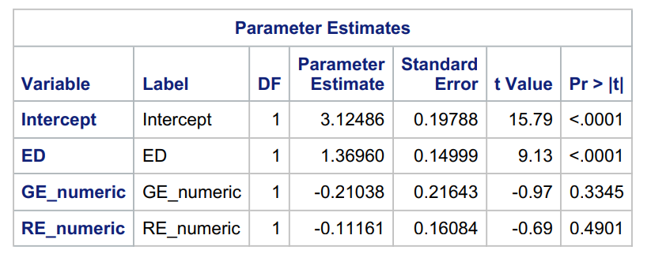
Source: Author’s estimates.

Table 2: The effects of spiritual freedom on economic prosperity (continued)
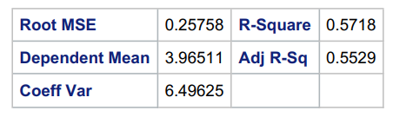
Source: Author’s estimates.

Appendix 1 : Descriptive statistics of spiritual freedom variables and LogGDP per capita
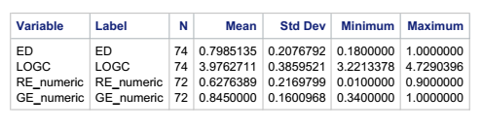

Appendix 2: Correlation matrix
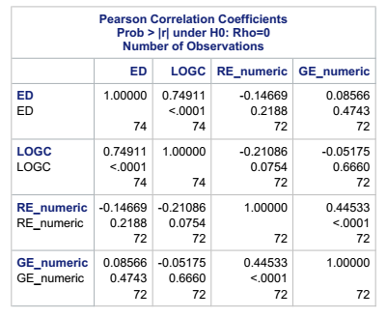

Appendix 3: Regression procedure global model (without parameter estimates already in the text of the article)
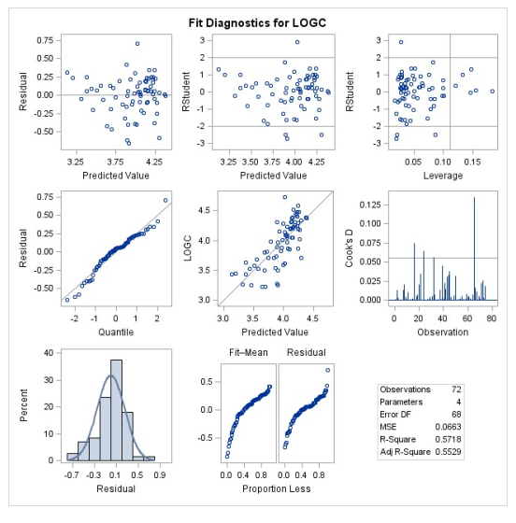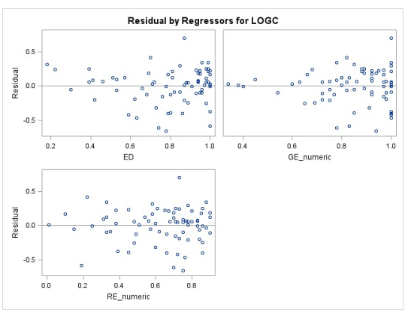
Appendix 4: Regression procedure with only European countries

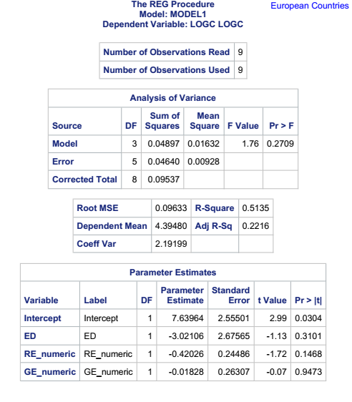

Appendix 5: Regression procedure with only Asian countries

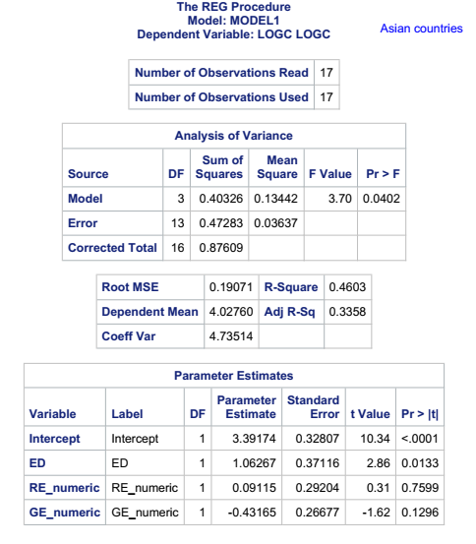

Appendix 6: Regression procedure with only African countries

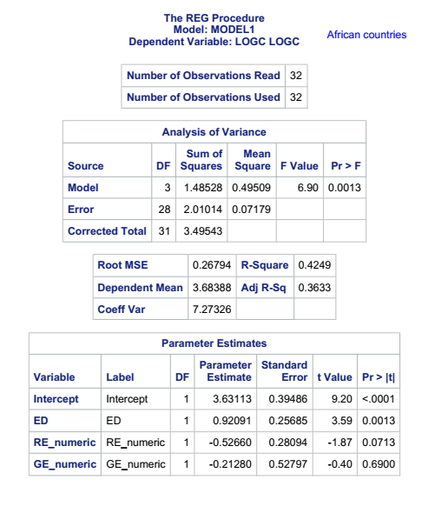

Appendix 7: Regression procedure with only American countries

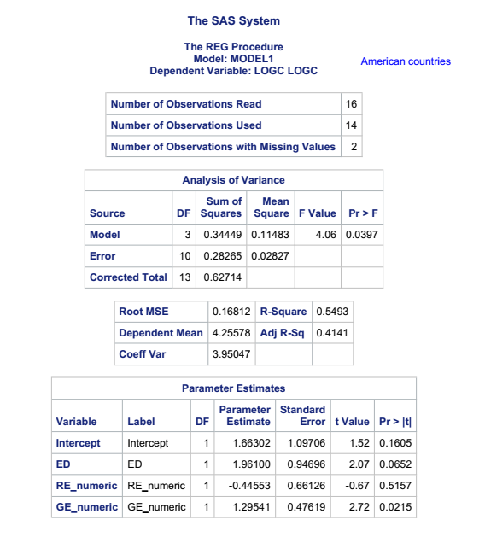

Appendix 8: List of all countries whose statistics have been used for the regression

 | Country | Continent
1 | Algeria | Africa
2 | Angola | Africa
3 | Benin | Africa
4 | Botswana | Africa
5 | Burkina Faso | Africa
6 | Cameroon | Africa
7 | Chad | Africa
8 | Côte d'Ivoire | Africa
9 | Congo, Dem. Rep. of the | Africa
10 | Egypt | Africa
11 | Eswatini | Africa
12 | Ethiopia | Africa
13 | Gambia | Africa
14 | Ghana | Africa
15 | Kenya | Africa
16 | Lesotho | Africa
17 | Liberia | Africa
18 | Madagascar | Africa
19 | Malawi | Africa
20 | Mali | Africa
21 | Mozambique | Africa
22 | Namibia | Africa
23 | Niger | Africa
24 | Nigeria | Africa
25 | Rwanda | Africa
26 | Senegal | Africa
27 | Sierra Leone | Africa
28 | South Africa | Africa
29 | Tanzania | Africa
30 | Togo | Africa
31 | Tunisia | Africa
32 | Zambia | Africa
33 | Bolivia | America
34 | Brazil | America
35 | Colombia | America
36 | Costa Rica | America
37 | Dominican Republic | America
38 | Ecuador | America
39 | El Salvador | America
40 | Guatemala | America
41 | Guyana | America
42 | Honduras | America
43 | Jamaica | America
44 | Mexico | America
45 | Paraguay | America
46 | Peru | America
47 | Suriname | America
48 | Uruguay | America
49 | Azerbaijan | Asia
50 | Bangladesh | Asia
51 | Cambodia | Asia
52 | China | Asia
53 | India | Asia
54 | Indonesia | Asia
55 | Jordan | Asia
56 | Kyrgyz Republic | Asia
57 | Laos | Asia
58 | Mongolia | Asia
59 | Nepal | Asia
60 | Pakistan | Asia
61 | Philippines | Asia
62 | Tajikistan | Asia
63 | Thailand | Asia
64 | Timor-Leste | Asia
65 | Vietnam | Asia
66 | Albania | Europe
67 | Armenia | Europe
68 | Belarus | Europe
69 | Bosnia and Herzegovina | Europe
70 | Georgia | Europe
71 | Moldova | Europe
72 | Montenegro | Europe
73 | Serbia | Europe
74 | Türkiye | Europe

Fordham Pope Francis Global Poverty Index Report 2022.
Paul A. Marshall, Religious freedom in the World, Rowman & Littlefield Publishers, Inc. 2008
David Boaz, The Libertarian Mind, (New York: Simon & Shuster, 2015),
John F. Early, Measurable Relationships Between Freedom and Prosperity and the Consequences for the Washington Consensus and New Economic Paradigm Cato working paper, 2023
Woodberry, Robert. The Missionary Roots of Liberal Democracy VL - 106 - American Political Science Review. 2012.
Brian J. REm. Is Religious Freedom Good for Business? A Conceptual and Empirical Analysis. Interdisciplinary Journal of Research on Religion, Volume 10 2014 Article 4.
Gill A, Owen JMIV. Religious liberty and economic prosperity: Four lessons from the past. Cato Journal 37(1): 115–134. 2017.
Rem, Clark, and Snyder (2014): Is Religious Freedom Good for Business? Interdisciplinary Journal of Research on Religion Vol. 10 (2014), Article 4.
Fox, J. What is religious freedom and who has it? Social Compass, 68(3), 321-341. https://doi.org/10.1177/00377686211012368.2021
Gill A, The political origins of religious liberty. New York: Cambridge University Press. 2008.
Grant C. (2017), The contribution of education to economic growth. K4D Helpdesk Report. Brighton, UK: Institute of Development Studies.
Power and al (2015), Building Capacity in Higher Education Topic Guide, HEART
UNESCO (2010) The Central Role of Education in the Millennium Development Goals, MDG Summit High-Level Round Table, 22/09/2010, United Nations, New York Secondary education
Fluchtmann , J., W. Adema and M. Keese (eds.) (2024), “Gender equality and economic growth: Past progress and future potential”, OECD Social, Employment and Migration Working Papers, No. 304, OECD Publishing, Paris, https://doi.org/10.1787/fb0a0a93-en.
It measures on a 10-point scale government laws, policies and actions that restrict religious beliefs or practices. The RE is comprised of 20 measures of restrictions, including efforts by governments to ban faiths, prohibit conversions, limit preaching or give preferential treatment to one or more religious groups.
See appendix 2.

